40.55: a)
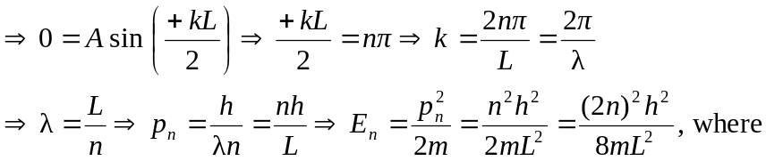
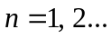
b)
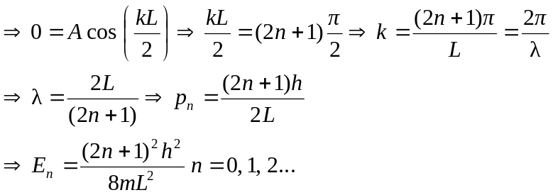
c) The combination of all the energies in parts (a) and (b) is the same energy levels as given in Eq. (40.9), where 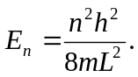
d) Part (a)’s wave functions are odd, and part (b)’s are even.

